CS349 ASSIGNMENT 02
ANIKET RAJPUT (170101007)
Drive Link for Traces:
https://iitgoffice-my.sharepoint.com/:f:/g/personal/anike170101007_iitg_ac_in/Enwx9FmwV69DrvLmWKI5jXQBAiIlvjxcq1Z685iRa2_XVg?e=kUxexu
01. PROTOCOLS USED AT DIFFERENT LAYERS BY THE APPLICATION
DATA LINK LAYER
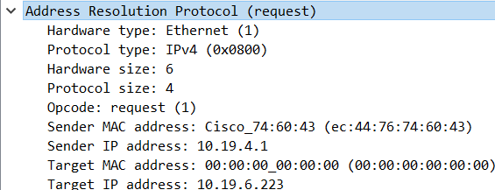
- ARP – Used for discovering the MAC address associated with an IP(IPv4) address. ‘Hardware and Protocol type’ specifies the network link protocol type and the internetwork protocol for which ARP request is intended. ‘Opcode’ gives the operation performed: 1 for request and 2 for reply.
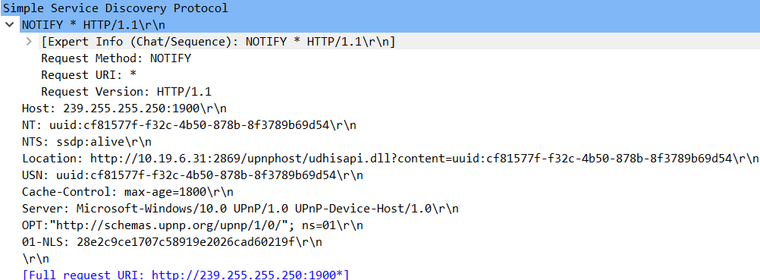
- SSDP – Used for discovering and advertising services and devices on a TCP/IP network. It is the basis of Universal Plug and Play protocol. It uses the HTTP method ‘NOTIFY’ to announce establishment or withdrawal of services and ‘M-SEARCH’ method to discover available services.
NETWORK LAYER
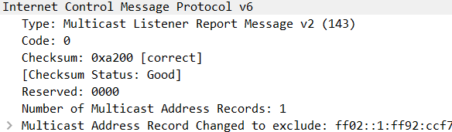
- ICMPv6 – Used to send error messages and operational information about success or failure during communication. Version 6 is used for IPv6 addresses. It consists of a ‘header’ and a ‘payload’. Header has 3 fields. ‘Type’ indicates error or information message. ‘Code’ indicates the level of detail of message. ‘Checksum’ provides a level of integrity verification. ‘Payload’ is the data or message.
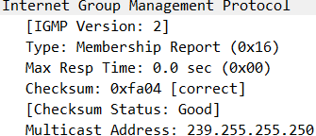
- IGMP – Used on IPv4 networks to establish multicast group memberships by host and adjacent routers. ‘Type’ depends on the version on IGMP used (2 and 3 in the experiment). ‘Max Resp Time’ specifies the required responsiveness of replies.
TRANSPORT LAYER
- TCP – Used to establish and maintain a network conversation through which application programs can exchange data. It defines how systems send packets to each other. ‘Sequence number’ gives the sequence of data byte depending on acknowledged ACK. ‘Acknowledgement number’ is next sequence number of ACK expected. ‘Data Offset’ specifies the size of TCP header. Contains 9 1-bit ‘flag’ bits. ‘Window size’ gives number of window sized units to be received. ‘Checksum’ is used for error checking.
- TLS – It runs on top of TCP and is designed to provide communication security over the network. TLS is used by websites to secure all communications between their servers and web browsers. TLS provides privacy and data integrity.
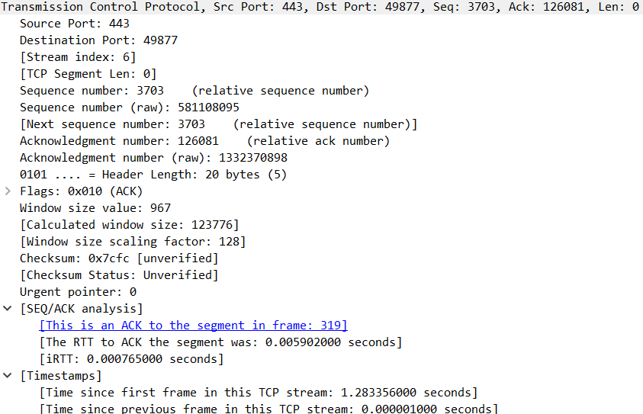
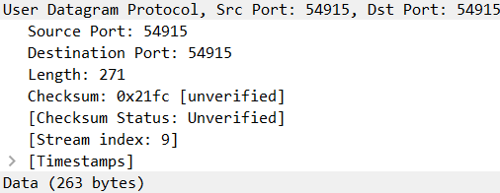
- UDP – It is an alternative communications protocol to TCP, used primarily for establishing low-latency and loss-tolerating connections between applications on the internet. Packet consist of ‘header’ and ‘data’. ‘Length’ specifies length in bytes of header and data. ‘Checksum’ is used for error-correction.
APPLICATION LAYER
- DHCP – It provides quick, automatic and central management for the distribution of IP addresses within a network and also used to configure the subnet mask, default gateway and DNS server information on device.
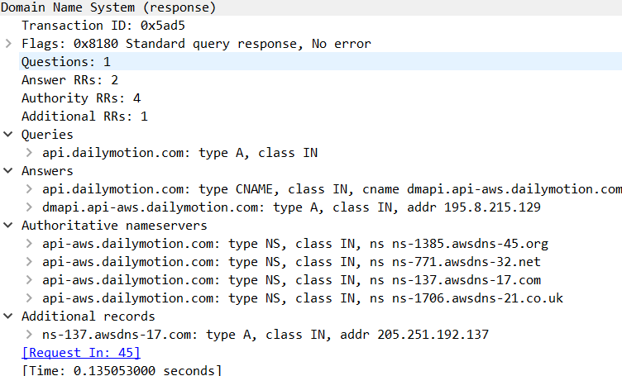
- DNS – It translates domain names to IP addresses so browsers can load internet resources. A DNS message consists of a ‘header’ and 4 sections. ‘Header’ contains fields of ‘identification’, ‘flags’, ‘no. of questions’, ‘no. of authority resource records (RR)’ and ‘no. of additional RR’s’. DNS specifies information elements for network resources which are recorded in resource records. Each record has a name, type and class specified. ‘TTL’ gives the count of seconds for which RR stays valid.

02. OBSERVED VALUES (FROM UPLOAD TRACE OF NOON)
- ARP
The ‘Destination’ field in this case ‘Broadcast’ as this protocol determines the MAC address of a given IP by request all systems in the local network. The ‘Source’ field is the address of sender of this request. My system uses ‘IPv4’ ‘Protocol Type’. The ‘Opcode’ distinguishes the request and reply packets. The ‘Target MAC address’ in this case is 00:00:00:00:00:00 as it is to be determined.
- SSDP
It employs two HTTP methods M-SEARCH and NOTIFY. During M-SEARCH most common ‘Destination’ address is ‘239.255.255.250’ which is used for multicast DNS. The ‘Source’ field is the address of sender of this request. It uses UDP ‘Protocol’ and the most common ‘Destination Port’ is 1900 which is used for Universal Plug n Play devices. ‘Time To Live’ field is associated with these packets to ensure duration of their validity.
- ICMPv6
The most common ‘Destination’ address associated with packets of this protocol is found as ‘ff02::16’ which is for Multicast Listener Discovery (MLD) capable router and is used by IPv6 routers. These packets have and associated ‘Hop Limit’ with them. They are used in IPv6 ‘Protocol’. These packets also have ‘Padding bits’ associated with them and ‘Router Alert’ field for routers to examine the contents of an IP packet more closely.
- IGMP
These packets have same function as ICMPv6 but they use IPv4 Protocol.
- TCP
For the given trace most common ‘destination and source ports’ were 443 and 49877. These packets had ‘acknowledgement number’ associated with them to keep check on lost frames. ‘Timestamps’ are used to keep record of time since first frame and previous frame in the stream. These packets also have ‘payload’ associated with them. These packets also have flags to distinguish between duplicate acknowledgement packets.
- TLS
These packets have same properties as TCP packets along with a security layer. There is field depicting the ‘Encrypted Application Data’.
- UDP
10.19.6.200 and 10.19.7.255 are most common source and destination addresses in UDP packets. The ‘Protocol Type’ of these packets is IPv4 and these packets have ‘Data’ associated with them.

03. PROTOCOLS
When we are uploading or downloading something we are sending or receiving data in respective cases. For uploading and downloading of videos the main protocols used at transport layer are TCP, TLS and UDP.
TCP (Transmission Control Protocol) enables the smooth flow of data and its automatic recovery. It detects errors and acknowledge sent and received data. It provides sequencing of data packets, flow control and error checking to ensure message delivery. TCP is used is by internet applications such as WWW, FTP (File Transfer Protocol), P2P etc. TCP also helps in network congestion avoidance. It works on the principle of 3-way handshake. For one application to send data to another, the two processes must first handshake i.e. they must send some segments to each other to establish the parameters of data transfer. The client application process first informs the client transport layer to establish a connection. The client first sends a TCP segment and then server replies with a TCP segment. Then client sends a third TCP segment. This connection-establishment procedure is known as 3-way handshake. The client passes a stream of data. TCP directs it to a send buffer and this chunk of data will pass through the network layer.
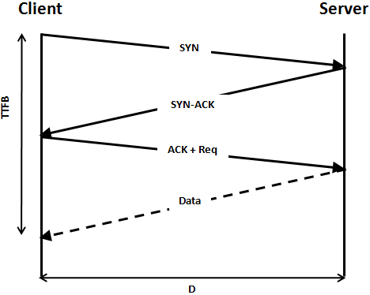
TLS (Transport Layer Security) protocol aims to provide privacy and data integrity between two or more communication computer applications. It creates a private, secure connection between a client and server. It encrypts the data transmitted. It also uses the handshake protocol to establish connection between hosts.
UDP (User Datagram Protocol) uses a simple model of communication. Due to lack of handshaking dialogues, there exist an unreliability in the network. There are no protective measures from disorders, nondelivered and duplicate protection. There is no extensive error checking mechanism. But it provides a faster connection than TCP.
At Internet layer, IP (Internet Protocol) is a useful protocol. It is a protocol for routing and addressing packets of data so that they can travel across networks and arrive at the correct destination. Every device of domain that connects to the Internet is assigned an IP address, and as packets are directed to the IP address attached to them, data arrives where it is needed.
04. (a) HANDSHAKING SEQUENCE
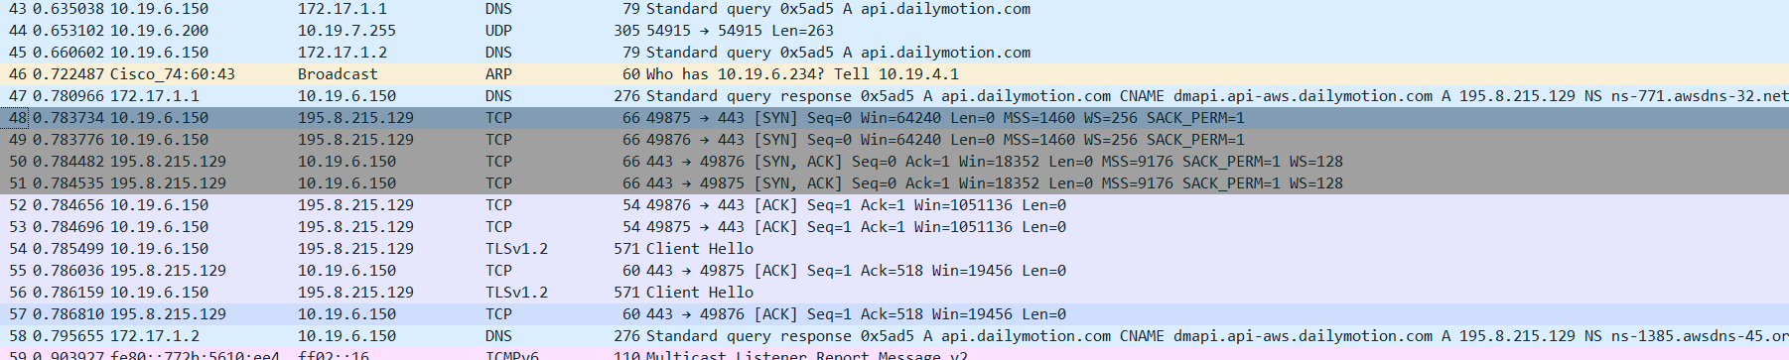
The packets from 48 onwards are involved in the ‘three-way handshaking’. These packets are exchanged to establish the TCP connection. The ‘info’ of these packets suggests the parameters defined for the communication between the hosts such as MSS (Maximum Segment Size) and WS (Window Scale). SYN is sent by my system to host and SYN/ACK is received from the host by my system indicating the formation of TCP connection. On receiving the SYN/ACK from host, final ACK is sent to the host by my system.
(b) PACKETS ACKNOWLEDGEMENT
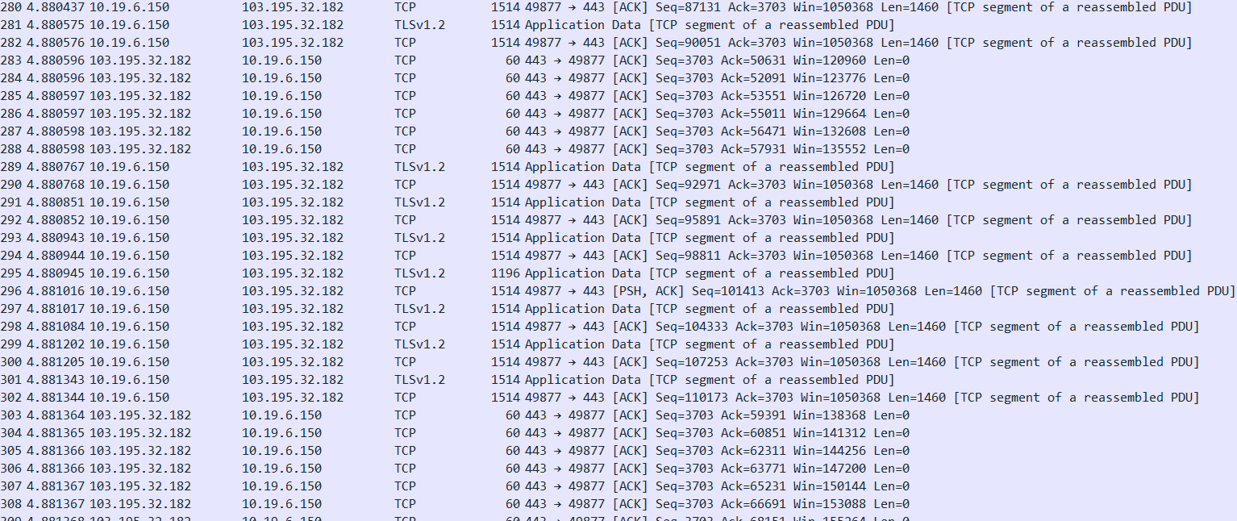
The above screenshot portrays that during the upload a stream of packets is sent by my system and according to the TCP protocol it waits for the acknowledgement for the sent packets to be received from the host. If an acknowledgement for a particular packet is not received then a that packet will be sent again and the system will again wait for acknowledgement. The maximum number of continuous packets to be sent depends on the number of acknowledgements to be received and the maximum window size decided during establishment of TCP connection.
05. STATISTICS
 | 12:30 |  | 17:30 |  | 23:30
 | Upload | Download | Upload | Download | Upload | Download
Throughput  (Packets/sec) | 323.7 | 837.5 | 303.2 | 809 | 787.3 | 609.1
RTT (ms) | 0.649 | 0.665 | 0.761 | 0.706 | 0.407 | 0.528
Avg. Packet size (Bytes) | 1043 | 967 | 985 | 974 | 1002 | 945
No. of Packets Lost | 0 | 0 | 0 | 0 | 0 | 0
No. of UDP packets | 1931 | 2767 | 4189 | 2404 | 1427 | 5701
No. of TCP packets | 78105 | 230407 | 81110 | 229526 | 82906 | 231901
No. of responses w.r.t 1 request | 0.339 | 1.999 | 0.359 | 1.999 | 0.378 | 1.998

06. MULTIPLE SOURCES
In the given experiments during uploading, data was sent to 103.195.32.182 in the noon and evening while at night data was sent to 103.195.32.183.
During downloading, data was received from 188.65.126.33 in the noon, 188.65.126.38 in the evening and at night data was received from 103.195.32.6.
The reasons behind changing of IP address for a host can be –
- If ISP changes the center or router responsible for the address.
- Failure in ISP’s network causing routing tables to rebuild.
- Load balancing across a server to distribute network traffic.
- DHCP lease time for the given IP address has expired.

